# Semester Project Phase 2 (Website Information) – Group B

GROUP OVERVIEW – GROUP B

## Group Members

* **Michael Ng**: Team Leader
* **Emily Ervin**: Document Manager
* **Preston Ware**: Lead Developer
* **Aaron Henderson**: Lead Designer
* The Quality Manager is shared equally across the team.
* Our team communicates using Discord. We also have set up a GitHub repository for later use.
* We meet using Zoom, and meetings prior to the 2nd interview have been recorded (inclusive).

## Client Information

* **Client**: Lindsay Roberts
* **Business**: Twisted Vinyl
* Lindsay Roberts is the owner of a small family business named “Twisted Vinyl”.
* The company mainly sells decorated T-Shirts, but also do other types of decorations such as Sublimination Printing, Vinyl decals on car windows, home decorations, etc.
* She plans on updating the website on the days to come and hopes to turn the company into a profitable and formal business.

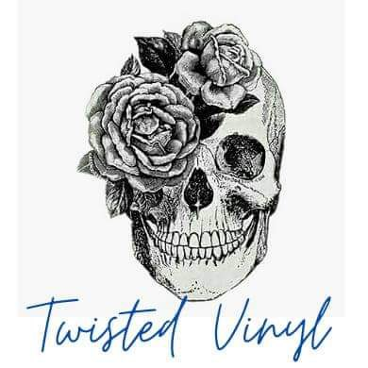

## Site Mission Statement

* *To make sure our customers are happy with the finished design.*

Website Content Details (Steps 1 & 2)

* The webpages we will include, and their descriptions are:
  + Homepage
    - This page will act as the main page, giving a *very* brief overview of the company and what it does. It will also include a small about me section as well as a link to the About Us webpage.
    - This page includes brief Customer Reviews and Comments alongside featured products.
    - The website’s design will be based off this design: [Danielle Clough – Embroiderer from South Africa](https://danielleclough.com/).
  + About Us
    - This page talks about the founding of the company, as well as its owner’s reasons for starting the company and their background.
  + Contact Us
    - This page can be used if a consumer wants to get in touch with the owner.
    - Customers can order special appointments with the owners for products like car window vinyl. However, they are required to contact Lindsay to get an appointment time and let her know what special decoration they want.
    - Customers can find Lindsay’s contact information (Phone Number and Email) here.
  + Gallery
    - This page is mainly used to show off pictures of what each finished product may look like.
    - This page may also contain customer reviews of each product.
    - Most of the photos shown here will be provided by Lindsay.
  + Shopping Page
    - This page allows the consumer to buy T-Shirts and other products from the website.
    - Special Orders will be included here. A quick link to the Contact Us webpage will be provided here.
* Note: Website links on all the webpages will include links to the Home, Shopping, and Contact Us webpages.

Website Design and Diagrams (Steps 3 & 4)

## Color Theme

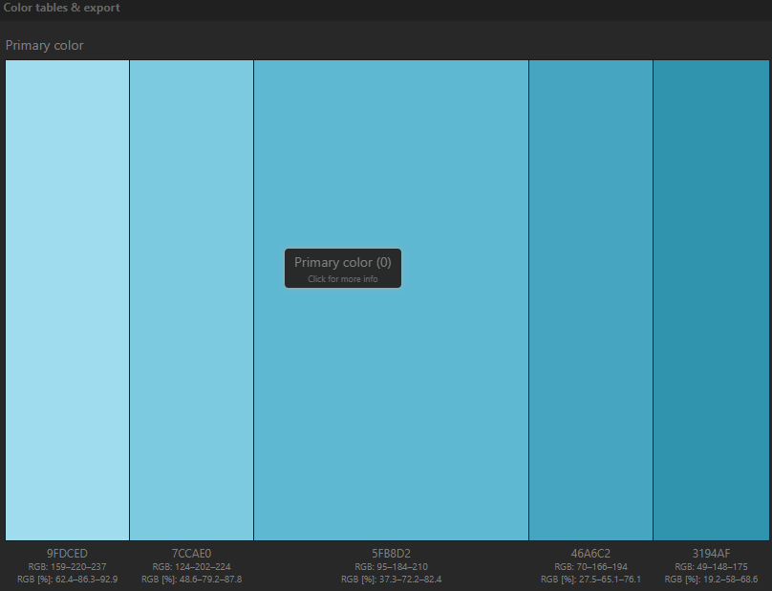

* This color theme has been approved by the client, Lindsay, in the 3rd interview.
* Hexadecimal codes: 9FDCED, 7CCAE0, 5FB8D2, 46A6C2, 3194AF. These are ordered from lightest to darkest.
* Contains shades of light teal and dark teal.

## Diagrams

* The Client, Lindsay Roberts, approves of the design of both websites. Lindsay also requested to make the website more “edgy”. This means changing the font and altering the website theme a little.

### Homepage

Picture of the proposed diagram of the Homepage. Design created by Lead Developer, Preston Ware.
Contains an extremely brief Welcome and About Us section, with Featured products below the sections.

* Picture of the homepage diagram (created by Lead Developer, Preston Ware). Contains an extremely brief Welcome and About Us section, with Featured products below the sections. The ribbon contains links to the other parts of the website.
* The design of the footer is to be determined but will likely have links to other parts of the website, like the footers of other business websites.
* The Colorblindness concern has been tested using Windows 10’s Color Filter setting (Grayscale). All text in the page is readable.

### Shopping Page

* Picture of the Shopping Page diagram (created by Team Leader, Michael Ng). Contains links to other parts of the website and has items ranging from T-Shirts to Decorations. When the user presses the photo of the product, they will be taken to the page of that specific product and pressing the + circle will add that item to the cart and increment the number above the cart by 1. The description of the product will always be to the right of the product.
* Note the search bar in the upper-right corner. It helps a user find what they are looking for very quickly, if they know what they want.
* The Colorblindness concern has been tested using Windows 10’s Color Filter setting (Grayscale). All text in the page is readable.
* The Client, Lindsay, asked if this diagram could be “less blocky”. The concern will be addressed in Phase 3.

Visual Elements (Steps 5 & 6)

## Significant Visual Element (Banner)

* This is a banner created by Lead Designer Aaron Henderson. It features the company logo to the left and the website mission statement to the right. “We make sure our customers are happy with the finished design.” (Approved)

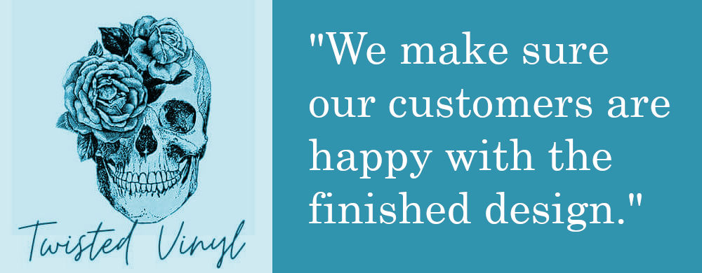

## Sample Photos (These will be added to the Gallery/Homepage)

* The following photos are some sample pictures that Lindsay requested to be put on the site.
* Note: Some of these products may appear edgy. Beware!

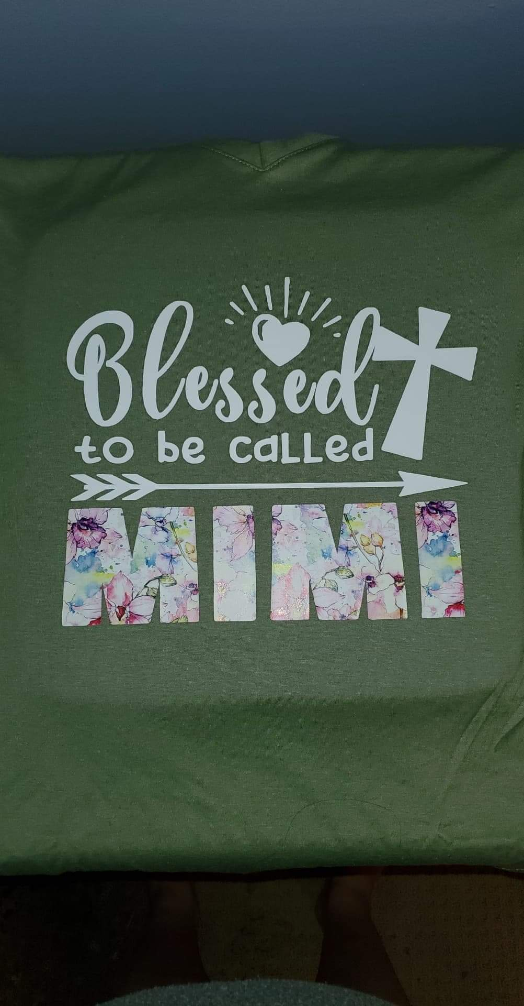 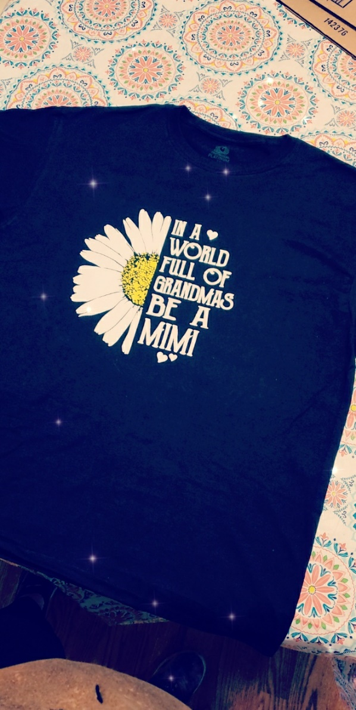

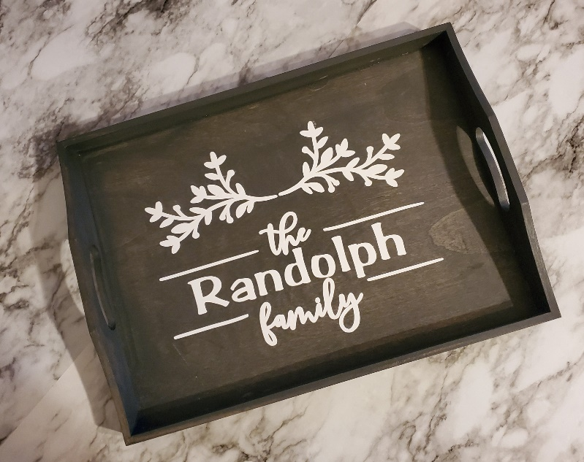 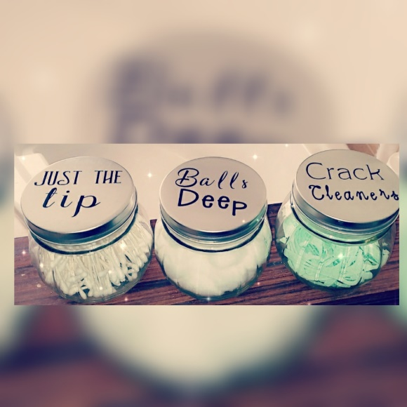

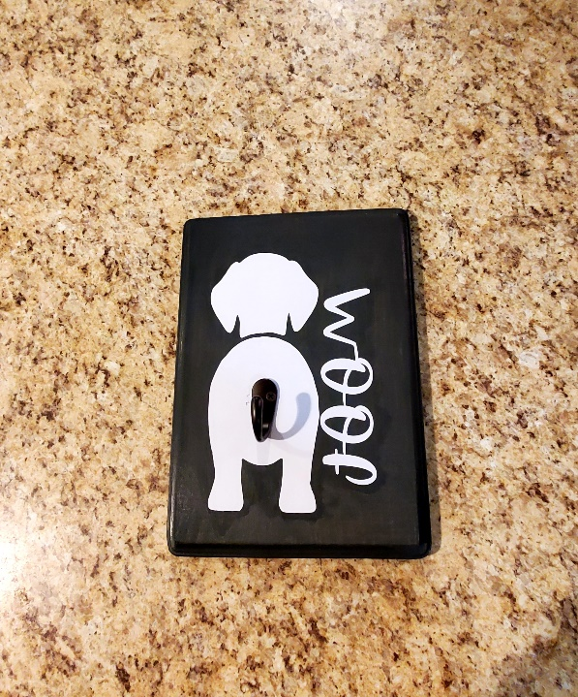 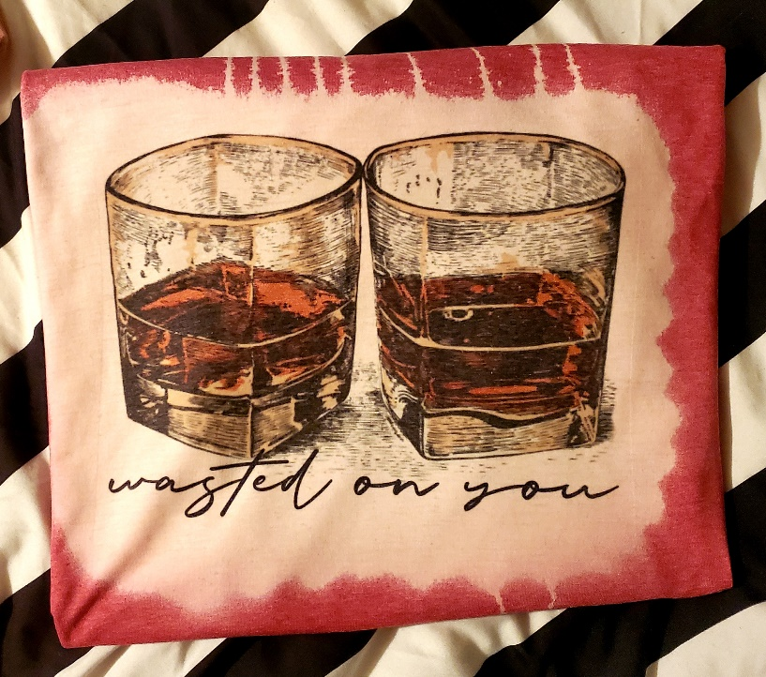

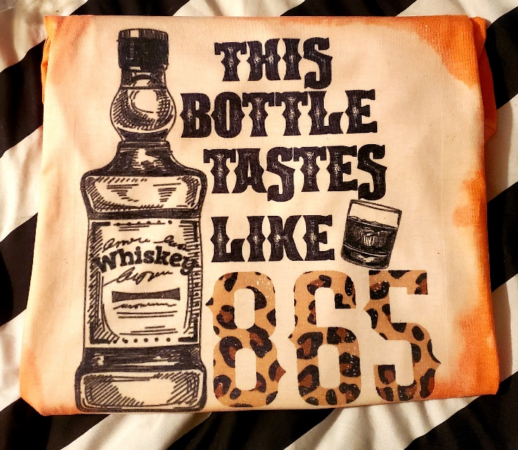 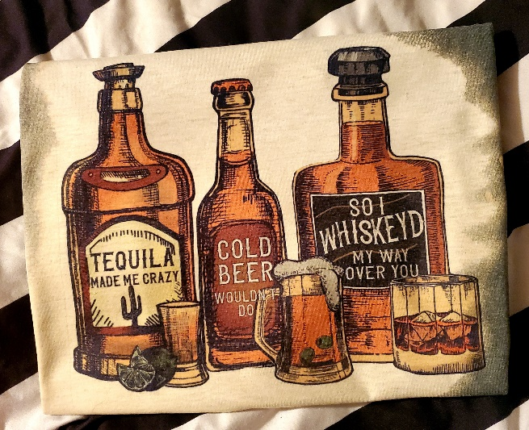

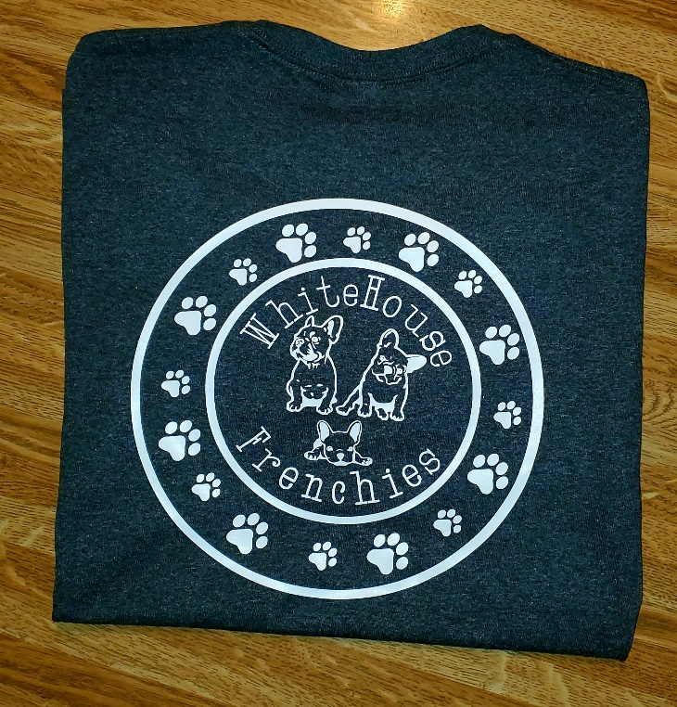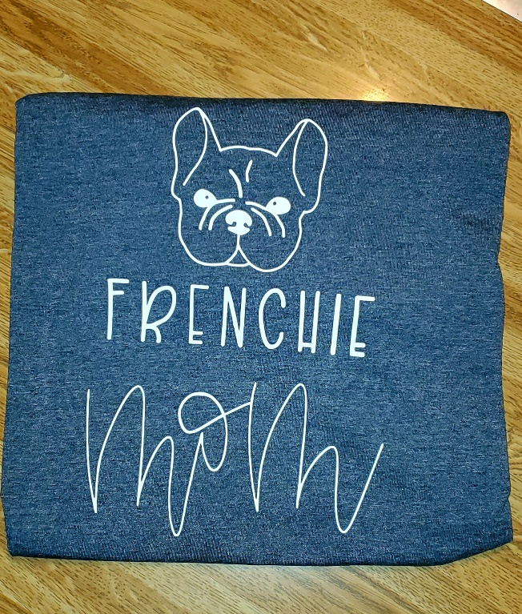

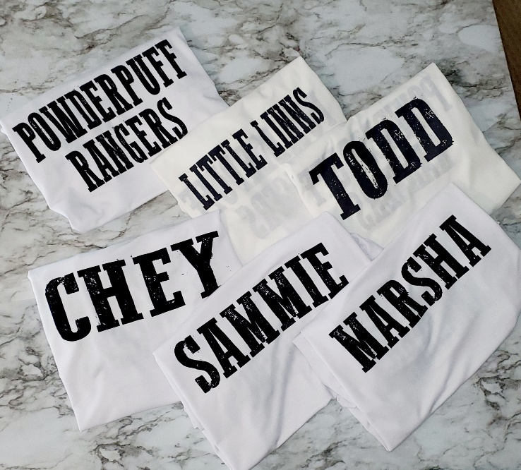 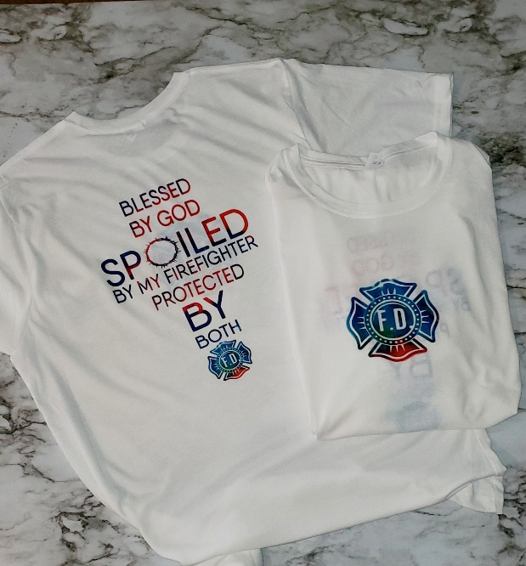

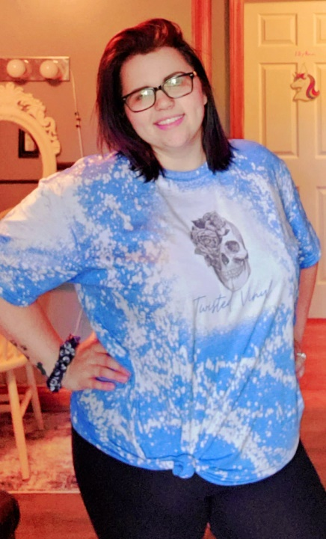 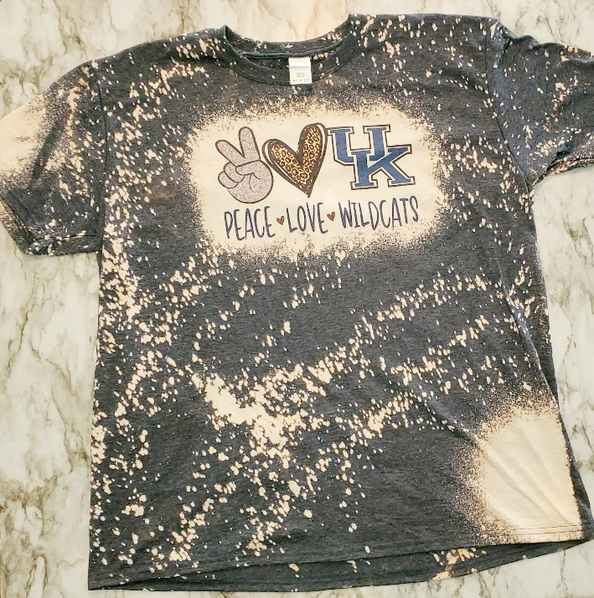

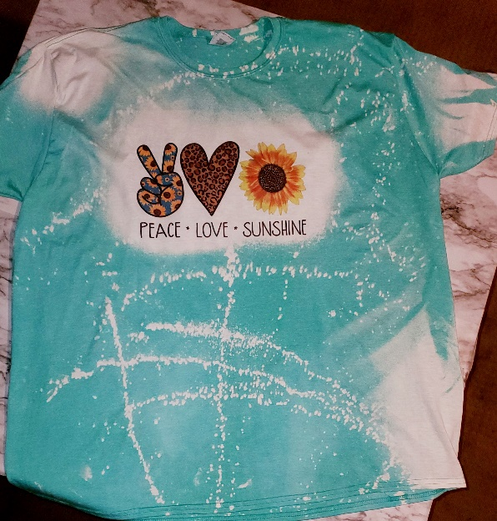 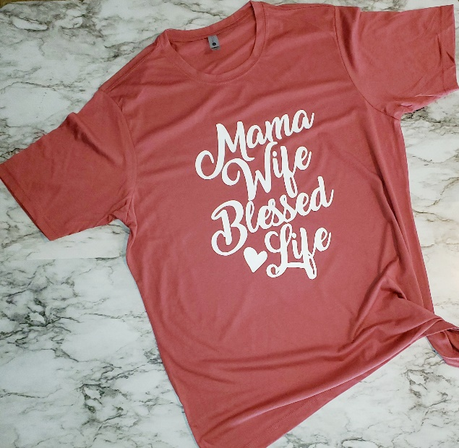

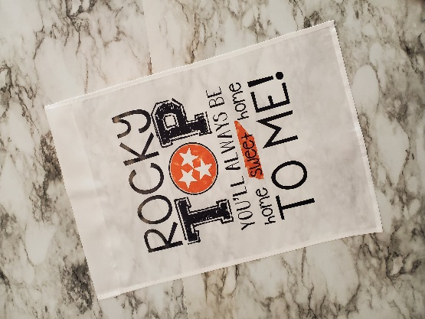

Miscellaneous

## Anticipated Key Components

* Gallery page.
* Reviews and Comments about Products
* Options that allow the user to change the color of a product while browsing.

## Interviews and Descriptions

* Interview 1 (Friday, February 12, 2021 – 11:30AM to 12:00PM): Introductions with the client, Lindsay, and some initial questions about the project, webpage, and business were asked. We were introduced to the business and what it does.
* Interview 2 (Wednesday, February 17, 2021 – 10:00PM – 10:10PM): Follow-up questions with Lindsay were asked.
* Interview 3 (Thursday, March 11, 2021 – 4:00PM – 4:12PM): Questions with Lindsay about her preferred website design, confirmation of the color scheme, and requesting permission to create a banner that fits the website’s theme. Diagrams and Banner are to be made by Lead Developer (Preston Ware) and Lead Designer (Aaron Henderson) respectively. Next interview is planned to make sure Lindsay is content with the website diagrams and banner.
* Design Meeting 1 (Saturday, March 20, 2021 – 9:40PM – 9:47PM): A quick meeting requested by Lead Developer, Preston Ware, to go over important design details in preparation for Phase 3. Website diagrams have been adjusted accordingly based on details obtained from the meeting. Sometime after the meeting, the Lead Developer, Preston Ware, personally spoke to Lindsay to confirm whether the designs are up to her standards.

Design Meeting Summary

* + Products should “pop” when the client goes onto the site. They should see the products first. (Homepage)
  + The blue background looks “soft”. Keep the blue “small” in certain places, like using it as an underline and a sub color.
  + Instead of putting an About Me on the homepage, it should be dedicated only to the About Me homepage.
  + Less cluttering of text; try to put more text in a longer space instead of in a smaller one.
* Interview 4: Personal meeting with Lead Developer Preston Ware and Client Lindsay Roberts. Preston went over the diagrams with Lindsay as well as his design recommendations in Design Meeting 1. Lindsay approves of both diagrams, with some suggestions on each webpage. (These suggestions are listed under Diagrams)